
First International Workshop on Nonhydrostatic Numerical Models

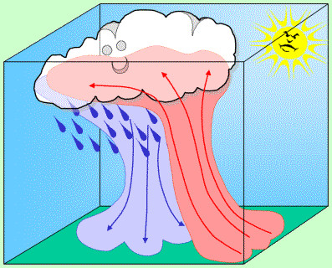
29 September – 1 October, 2010

Kyoto, Japan

1st Circular and Call for Papers

The First International Workshop on Nonhydrostatic Numerical Models (NHMs) will be held in Kyoto from 29 September to 1 October, 2010 to provide a scientific forum to discuss all aspects related to nonhydrostatic numerical models. The workshop is organized by the Meteorological Society of Japan (MSJ) Research Subcommittee on NHMs.
Papers are solicited in all aspects relevant to NHMs ranging from Large Eddy Simulation (LES) models to nonhydrostatic global models, including dynamical frames, physics schemes, data assimilation schemes, predictability and applications to mesoscale phenomena, such as tropical cyclones and heavy precipitations. Development of NWP systems is also a great concern to this workshop.
Please submit your short abstract (not more than 200 words) by email to the address nhm-ws2010@kugi.kyoto-u.ac.jp by 31 May, 2010, using the application form attached below. Program will be determined in July, 2010. Extended abstracts in a PDF format (not exceeding 2 pages and 3MB) must be submitted electronically by 31 July, 2010, to the same e-mail address above. All of the abstracts, extended abstracts, and presentations will be made available on a web site under permission of the authors.
For additional information, please contact to :
E-mail address: nhm-ws2010@kugi.kyoto-u.ac.jp

FAX: +81-75-753-4273
Web: http://www-clim.kugi.kyoto-u.ac.jp/nhm-ws/ws2010/

Program Committee (tentative):

Takehiko Satomura（Kyoto University）Chair

Junichi Ishida (Japan Meteorological Agency)

Toshiki Iwasaki (Tohoku University)

Teruyuki Kato (Meteorological Research Institute)
Hiroshi Niino (University of Tokyo)
Kazuo Saito (Meteorological Research Institute)
Masaki Satoh (University of Tokyo)

Kazuhisa Tsuboki (Nagoya University)

********** Application form **********

Authors:

Organizations:
Title of presentation:

Abstract:

Address of the representative author
Email:
Tel and Fax:

Postal mail address:

